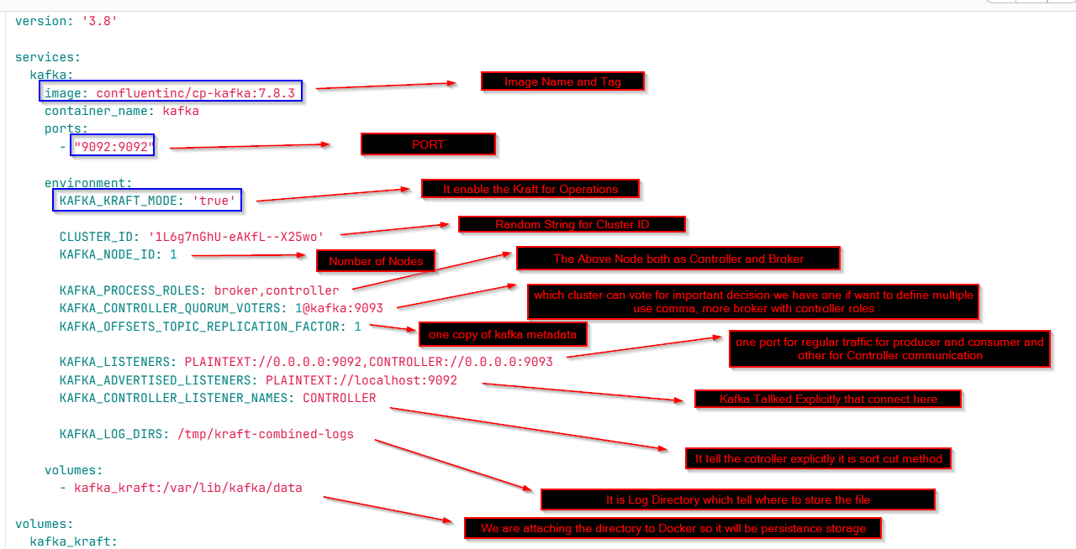

Using kafka cli
For troubleshooting

Docker exec -it <docker_id or name> kafka-topics –list –bootstrap-server localhost:9092
ENTER
You can see the topics name which we created
Lets check events

Docker exec -it <docker_id or name> kafka-topics –list –bootstrap-server localhost:9092

you can check the documentation
If you don’t want this go to the inside the cli of docker

Kafka-console-consumer
Use kafka-console-consumer to consume records from a topic.
It reads data from Kafka topics and outputs it to standard output. 